Animal Shelter Database

About the Project
This project is an Animal Shelter database for the Austin Animal Center that manages animals of different breeds and ages.

This project exists to provide a way to manage incoming and outgoing animals to the animal shelter with an authenticated admin user(s). The project also demonstrates the creator’s knowledge of CRUD principles in Python, database modification, and user creation within the CS-340 Client/Server Development online course at Southern New Hampshire University.

Getting Started + Setup

Programs:
Codio - Online IDE
Alternatives:
- Jupyter Notebook - Website
- Visual Studio Code - Download
- Create a new project and name it “Animal Shelter”. In the file directory of that project, create a folder called “datasets”. Create a .csv file named “aac_shelter_outcomes.csv”
- In the terminal of your IDE, change your directory to the datasets folder using “cd ./datasets”
- Type in the terminal:
“mongoimport --type=csv --headerline --db aac --collection animals --file aac_shelter_outcomes.csv”
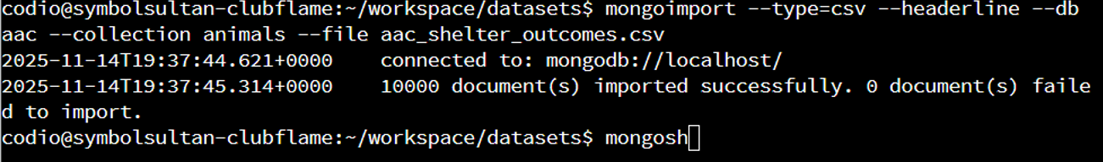
- Wait for the files to import and if you see the following message, the files are imported correctly.
- Enter MongoShell using the “mongosh” command and type “use admin” to create a user with reading/writing permissions within the Austin Animal Center’s Database with the following command:
“db.createUser({user: “aacuser”, pwd: “(Password)”, roles: [{role: “ReadWrite, db: “aac”}] })”
- Using Codio or IDE of choice, create two files in the project’s directory: A Python file for coding the CRUD module so you can manipulate data in the database, and a Jupyter Notebook file to write code for the Dash App view and controller components, as well as HTML code for the app’s design. Once the files are created, the project is ready to be coded and worked on.

Usage and Functionality
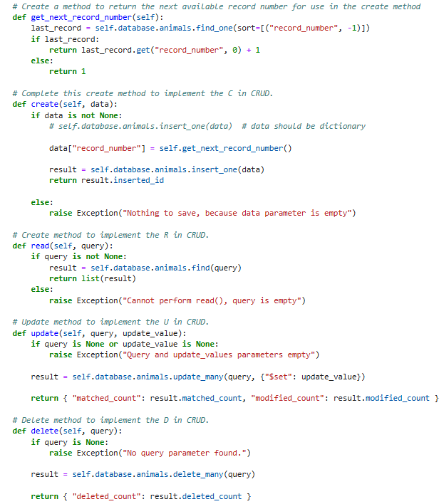
Code Example:
- get_next_record_number() - Generates record numbers for new records into MongoDB used for other methods. Works behind the scenes for the Create() method.
- Create() - Creates a new record for an animal.
- Read() - Retrieves existing documents in MongoDB of a given attribute (name, color, etc.).
- Update() - Updates data in existing documents by targeting a given attribute.
- Delete() - Deletes an existing document from the database, targeting a given attribute.

Tests
Filtering animal types based on:
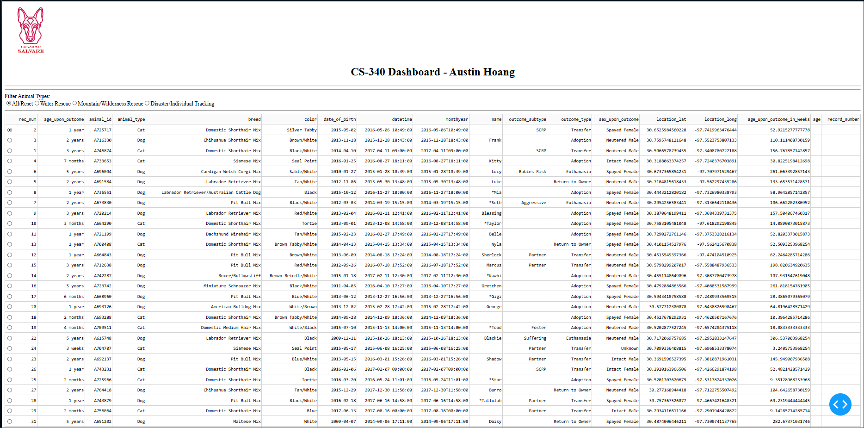
All/Reset:

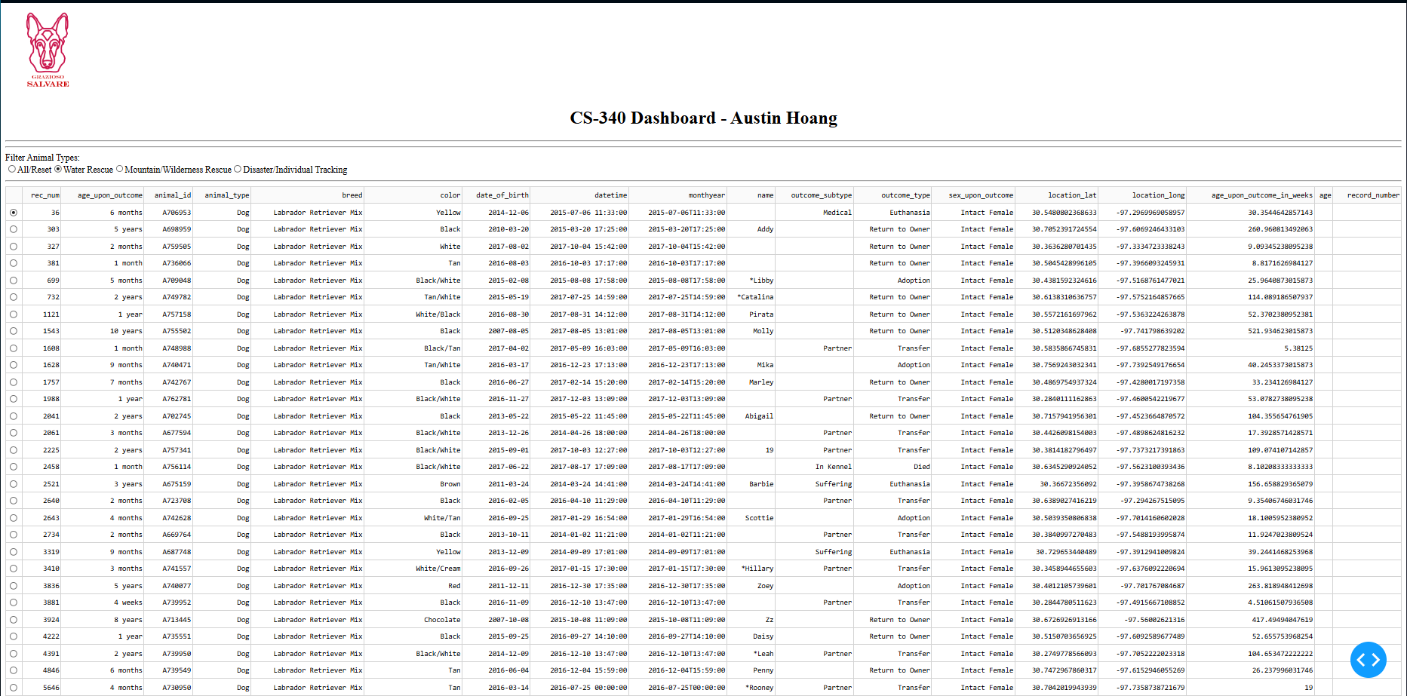

Water Rescue:

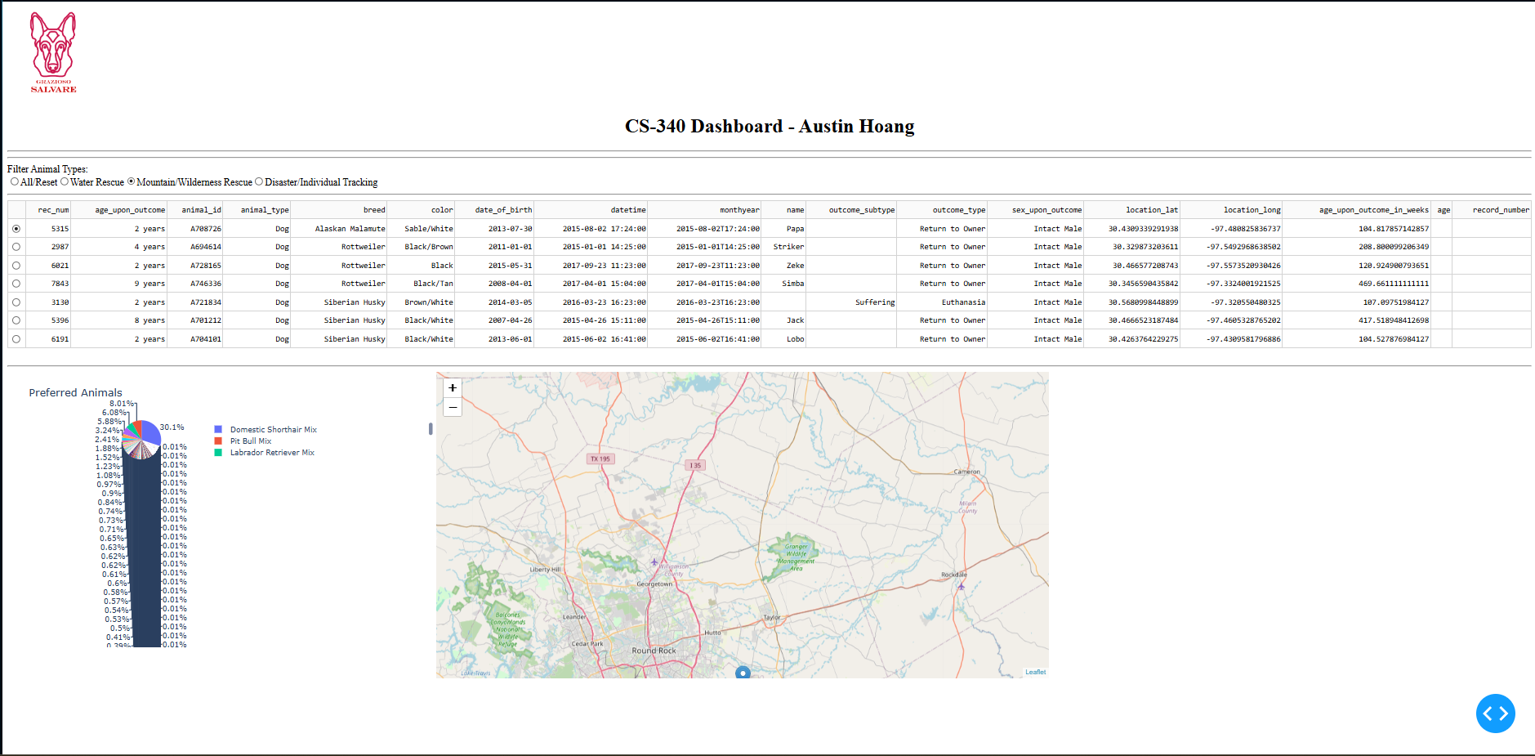
Mountain and
Wild Rescue:
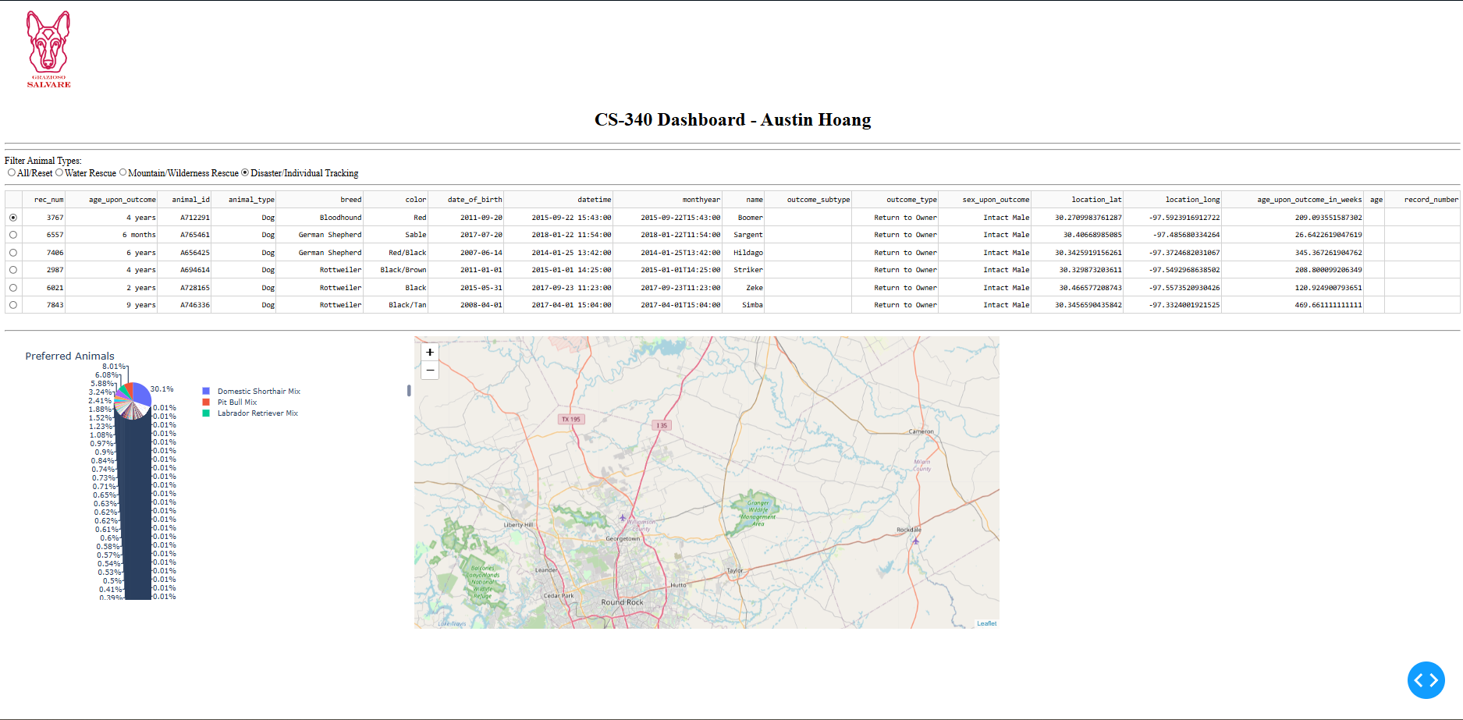
Disaster/Individual Tracking:

Functionality
The function of this dashboard gathers and displays data on animals based on certain rescue types, while filtering out animals that do not meet the criteria. The screenshots are tests of the function in action, along with a map and pie chart of animal breeds in the last two screenshots.

Tools
MongoDB, Python, and Dash were used as the main tools in this Dashboard project.
MongoDB has a flexible schema, allowing for varying data structures without causing the dashboard to crash or have a need for hard coding. MongoDB can also scale horizontally, which is fitting for large datasets, something the animal shelter would have for such a large volume of animals.
Python is the core programming language and used for its clear syntax, as well as its compatibility with MongoDB. Python’s clear syntax keeps code clean and easily readable. Python is available on multiple platforms and has various libraries, including synergy with MongoDB.
Dash is used to implement the view and controller of the web application. Dash is a framework in Python, which helps with synergizing with the previously listed tools. Dash also has interactivity features through dcc.RadioItems and dash_table.DataTable for filtering items and displaying the animal data table respectively. The controller when used with Dash awaits user inputs, then executes queries in MongoDB based on what filter is used, and updates the charts dynamically without needing to refresh the page.
Challenges:
One of the more prominent challenges of the project was learning all the tools used for this project. As someone who had little experience with Python and mainly used C++ and Visual Studio, picking up Jupyter Notebook took some time getting used to. When starting and setting up the project in Module One, I initially thought I did something incorrectly and tampered with the files, accidentally deleting something I could not recover. This caused me to request assistance in resetting the entire project so I can set it up properly.
I had some experience with web applications, creating an ASP.Net Core web application my sophomore year, so Dash and the HTML code were things that felt familiar but still new to use. There was also the occasional major coding bug that caused the entire application to break, which was the case coding callback routines in Module 6. I was able to overcome these challenges by seeking guidance with the professor and utilizing the feedback given to me as an opportunity to correct my mistakes and improve.

Contact
Austin Hoang
Bachelors in Computer Science
austin.hoang@snhu.edu

